PROJECT-8
AI News Aggregation and Email Notification Workflow
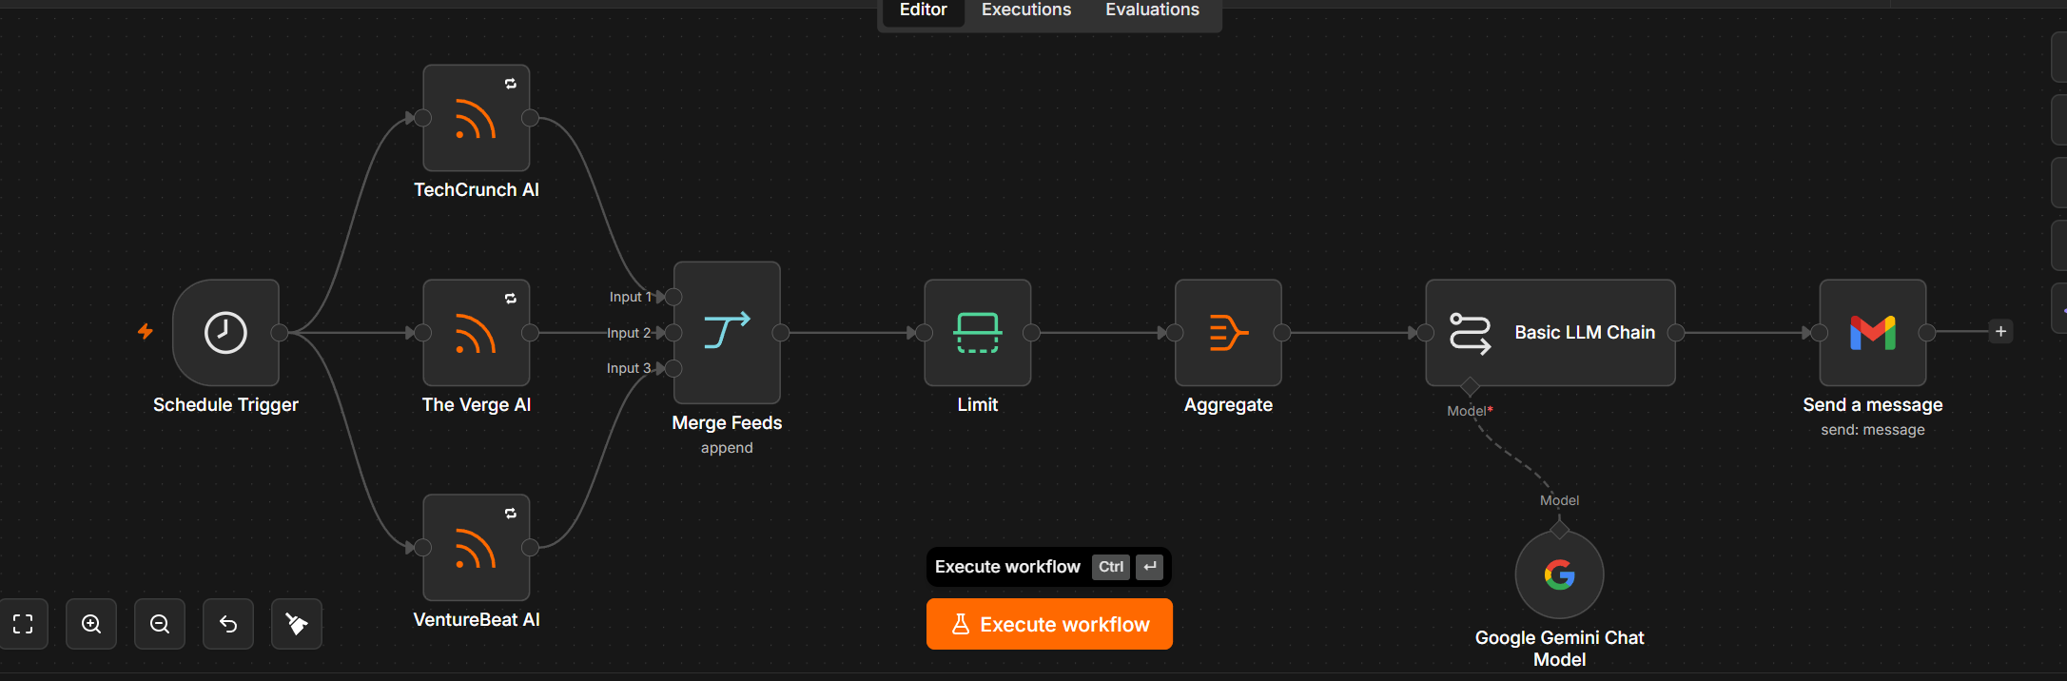
TECHCRUNCH : https://techcrunch.com/category/artificial-intelligence/feed/
VERGE : https://www.theverge.com/rss/ai-artificial-intelligence/index.xml
VENTURE BEAST : https://venturebeat.com/category/ai/feed/
Project Title
AI News Aggregation and Email Notification Workflow
Project Overview
This workflow automatically collects the latest Artificial Intelligence news from multiple RSS feeds, merges the news articles, limits the number of articles, summarizes them using Google Gemini, and sends the summarized report via Gmail.
This automation eliminates the need to manually browse multiple AI news websites every day by generating a single consolidated AI news digest.

Workflow Architecture
Schedule Trigger
│
▼
┌──────────────┐
│ TechCrunch AI│
└──────────────┘
│
┌──────────────┐
│ The Verge AI │
└──────────────┘
│
┌──────────────┐
│ VentureBeat │
└──────────────┘
│
▼
Merge Feeds
│
▼
Limit
│
▼
Aggregate
│
▼
Basic LLM Chain
│
▼
Send Gmail

Workflow Components
1. Schedule Trigger
Purpose
Starts the workflow automatically at a specified time.
Function
- Runs daily/hourly (based on schedule)
- Initiates all RSS feed requests simultaneously
Output
No data is generated. It simply triggers the workflow execution.

2. TechCrunch AI RSS Feed
Purpose
Fetches the latest AI news from TechCrunch.
Input
Schedule Trigger
Output
Example:
{
"title":"OpenAI launches new model",
"link":"https://...",
"description":"..."
}

3. The Verge AI RSS Feed
Purpose
Retrieves AI-related news articles from The Verge.
Output
A list of AI news articles in RSS format.

4. VentureBeat AI RSS Feed
Purpose
Collects AI news from VentureBeat.
Output
Latest AI-related articles.

5. Merge Feeds
Purpose
Combines articles from all three RSS sources into one dataset.
Mode
Append
Why Append?
Append mode simply stacks all incoming news items together without comparing them. This is ideal when combining multiple RSS feeds. The Merge node waits for all connected inputs before producing output.
Example
Before Merge
TechCrunch
-----------
News1
News2

The Verge
-----------
News3
News4

VentureBeat
------------
News5
After Merge
News1
News2
News3
News4
News5

6. Limit Node
Purpose
Restricts the number of articles passed to the AI model.
Why?
Without limiting:
- Too many API tokens
- Higher cost
- Longer execution time
Example
Total News = 85

Limit = 10

Output

News1
News2
...
News10

7. Aggregate Node
Purpose
Converts multiple news items into a single collection so they can be summarized together by one LLM prompt.
Why Aggregate?
The Basic LLM Chain processes each input item individually. Aggregating first allows one combined summarization request instead of many separate ones, reducing repeated prompts and improving efficiency.
Example
Before Aggregate
News1

News2

News3
After Aggregate
[
News1,
News2,
News3
]

8. Google Gemini Chat Model
Purpose
Acts as the AI model used by the Basic LLM Chain.
Responsibilities
- Reads all news articles
- Understands context
- Creates summaries
- Highlights important developments

9. Basic LLM Chain
Purpose
Uses Google Gemini to summarize the aggregated AI news.
Sample Prompt
You are an AI News Assistant.

Summarize the following AI news articles.

For each article provide:

• Title
• Summary
• Why it matters

At the end provide:

Top 3 important AI trends today.
Sample Output
AI News Summary

1. OpenAI releases GPT update
Summary:
...

Why it matters:
...

2. Google introduces Gemini feature
...

Top Trends

• AI Agents
• Enterprise AI
• Robotics
The Basic LLM Chain is designed for prompt-based AI workflows and integrates directly with supported chat models such as Gemini.

10. Gmail Node
Purpose
Emails the AI-generated summary to recipients.
Email Format
Subject
Daily AI News Summary
Body
Hello,

Here is today's AI news summary.

1.
...

2.
...

Top Trends

...

Workflow Execution Flow
Step | Node | Purpose
1 | Schedule Trigger | Starts the workflow automatically
2 | TechCrunch AI | Fetches AI news
3 | The Verge AI | Fetches AI news
4 | VentureBeat AI | Fetches AI news
5 | Merge Feeds | Combines all RSS items
6 | Limit | Reduces the number of articles
7 | Aggregate | Groups articles into one input
8 | Basic LLM Chain (Gemini) | Generates a consolidated summary
9 | Gmail | Sends the summary via email

Advantages
- Fully automated AI news collection
- Aggregates multiple trusted news sources
- Reduces manual effort
- Lowers AI token usage through limiting and aggregation
- Provides concise summaries instead of raw articles
- Delivers updates directly to email
- Easy to extend with additional RSS feeds or notification channels

Future Enhancements
- Add duplicate article detection
- Categorize news by topics (LLMs, Robotics, Startups, Research)
- Save summaries to Google Sheets or a database
- Send notifications via Slack, Microsoft Teams, or Telegram
- Generate weekly and monthly AI news reports
- Include sentiment analysis and trend tracking

